NAME: NITHISH KUMAR V R

ID: vrsathish15@gmail.com

Coding Challenges 1.0

# Write a java program to find whether the given number is prime or not.

**PROGRAM:**

public static void main(String[] args)

{

int number, i = 2;

boolean Count = false;

Scanner s = new Scanner(System.in);

System.out.print("Enter any number ");

number = s.nextInt();

while (i <= number / 2)

{

if (number % i == 0) {

Count = true;

break;

}

++i;

}

if (!Count)

System.out.println(number + " is a prime number.");

else

System.out.println(number + " is not a prime number.");

}

}

**OUTPUT :**

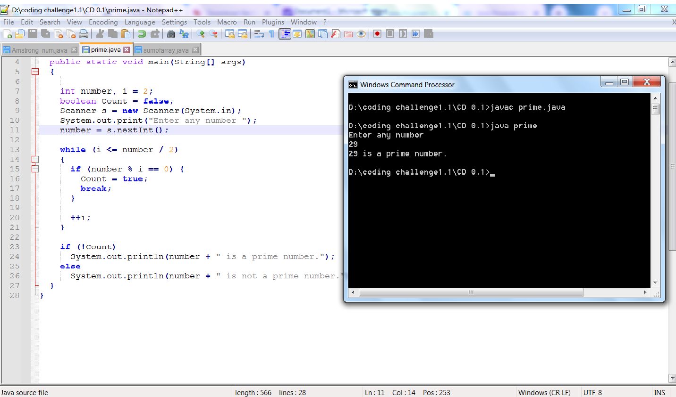

# 2. Write a java program to print your name and your name in reverse order.

## PROGRAM:

import java.util.Scanner;

public class revstring{

public static void main(String [] args)

{

String s;

Scanner scan = new Scanner(System.in);

System.out.println("Enter the String:");

s = scan.nextLine();

System.out.println("After a reverse String is:");

for(int i=s.length();i>0;i--)

{

System.out.print(s.charAt(i-1));

} } }

**OUTPUT:**

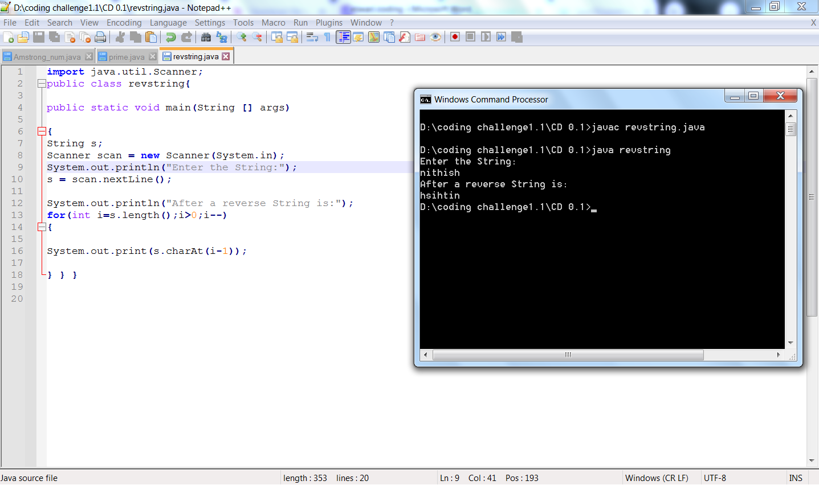

# 3.Write a java program to sum the elements of the array using for loop :a[11,22,33,44,55]

# PROGRAM:

# class sumofelement{

# static int arr[] = { 11,22,33,44,55 };

# static int sum()

# {

# int sum = 0;

# int i;

# for (i = 0; i < arr.length; i++)

# sum += arr[i];

# return sum;

# }

# public static void main(String[] args)

# {

# System.out.println("Sum of given array is "+ sum());

# }

# }

# OUTPUT:

# cd 0.1 3.png

# 4. Write the java code to sum the following array locations, a[2], a[4],a[6],a[8] from the array a[12,23,34,45,56,67,78,89,90]

# PROGRAM:

# class sumoflocationelement{

# public static void main(String[] args) {

# 

# 

# int sum;

# int[] a= {12,23,34,45,56,67,78,89,90};

# 

# sum= a[2]+a[4]+a[6]+a[8];

# System.out.println("sum of following array location : " + sum);

# }

# }

**OUTPUT:**

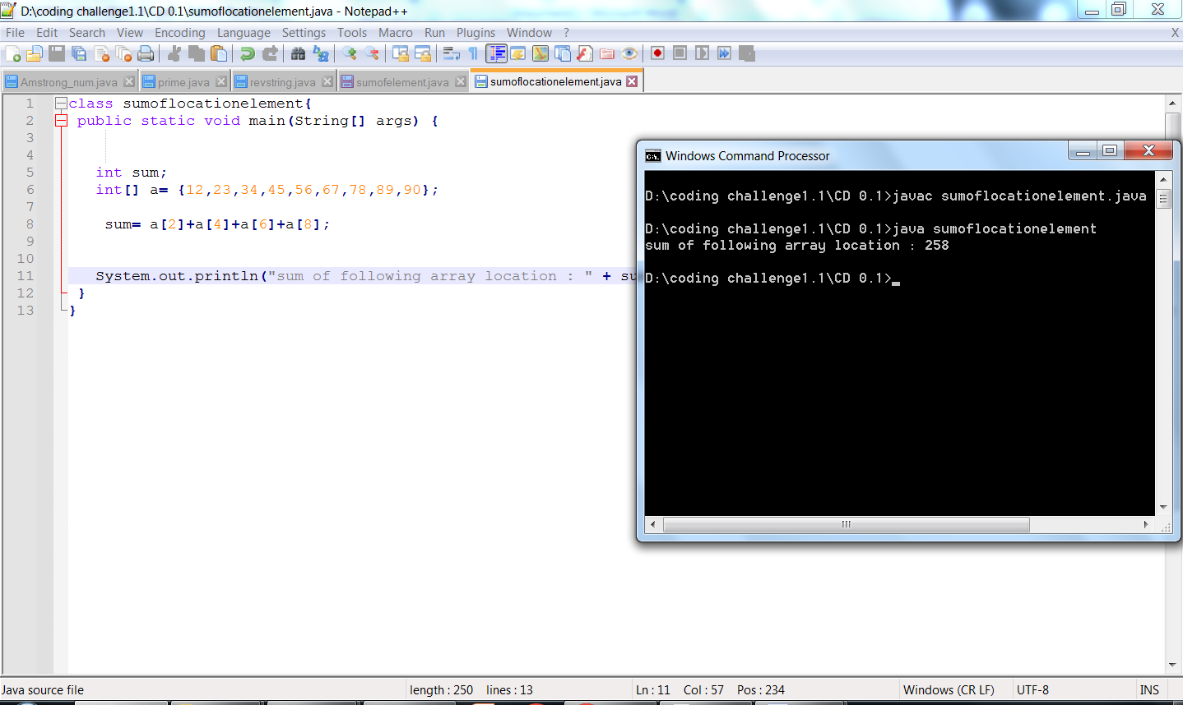

# 5.Write a java code for the following: string stg="welcome" read and convert it to uppercase letters as "WELCOME"

# PROGRAM:

# import java.io.*;

# class lowintouppcase

# {

# public static void main(String [] args)

# {

# String str = new String("welcome");

# System.out.println("lower case to upper case : "+ str.toUpperCase());

# }

# }

# OUTPUT :

# cd 0.1 5.png

# 6.Write a java code to separate the digits of the given number:967 as 9, 6,7

# PROGRAM:

# public class Separatedigit

# {

# public static void main(String [] args)

# {

# int num = 679;

# int digit1 = num /100%10;

# int digit2 = num /10%10;

# int didit3 = num %10;

# System.out.println(digit1+","+digit2+","+didit3);

# }

# OUTPUT :

# 

# 7.What will be the result of the following expressions:(work out using paper and pen)

**a. -5 + 8 * 6**

# b. (55+9) % 9

**c. 20 + -3*5 / 8**

# d. 5 + 15 / 3 * 2 - 8 % 3

# WORKOUT:

# WhatsApp Image 2022-10-02 at 4.43.38 PM.jpeg

**8. Find out the error in the following code:**

## Program:

public class JavaDemo {

public static main(String[] args) { System.out.println("Hello World Example);

}

}

## Output:

JavaDemo.java:3: error: invalid method declaration; return type required public static main(String [] args) **// Miss void method**

JavaDemo.java:5: error: unclosed string literal

System.out.println("Hello World Example); **//Unclosed Double Quotation**

1. errors

# 9. Find out the output of the following:

## Program:

public class MyClass{

public static void main(String[] args) { int[] dest = new int[]{0,1,2,3,4,5};

System.out.println(dest[0]+ dest[5]+dest[2]);

}

}

## Output:

Myclass1 7

# 10.Write a program that takes a number as input and prints its multiplication table upto 10.

Input a number: 8 Expected

Output :

8 x 1 = 8

8 x 2 = 16

8 x 3 = 24

...

8 x 10 = 80

PROGRAM:

import java.util.Scanner;

class Multiplicationtable

{

public static void main(String [] args)

{

Scanner mul = new Scanner(System.in);

System.out.println("Enter the value:");

int num = mul.nextInt();

for(int i=0;i<10;i++)

{

System.out.println(num+"x"+(i+1)+"="+(num * (i+1)));

}

}}

**OUTPUT:**

